A000-Afr-Egy-Figure-Female-Terracotta, Pigment-ca. 3500-3400 **BCE**

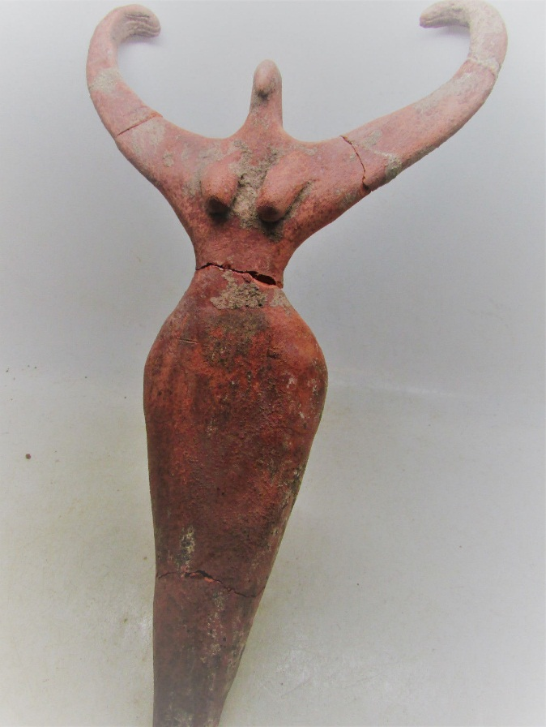 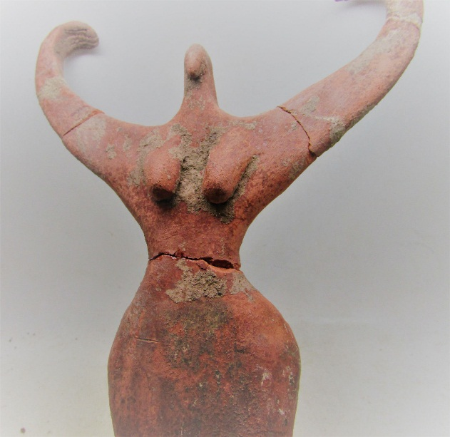

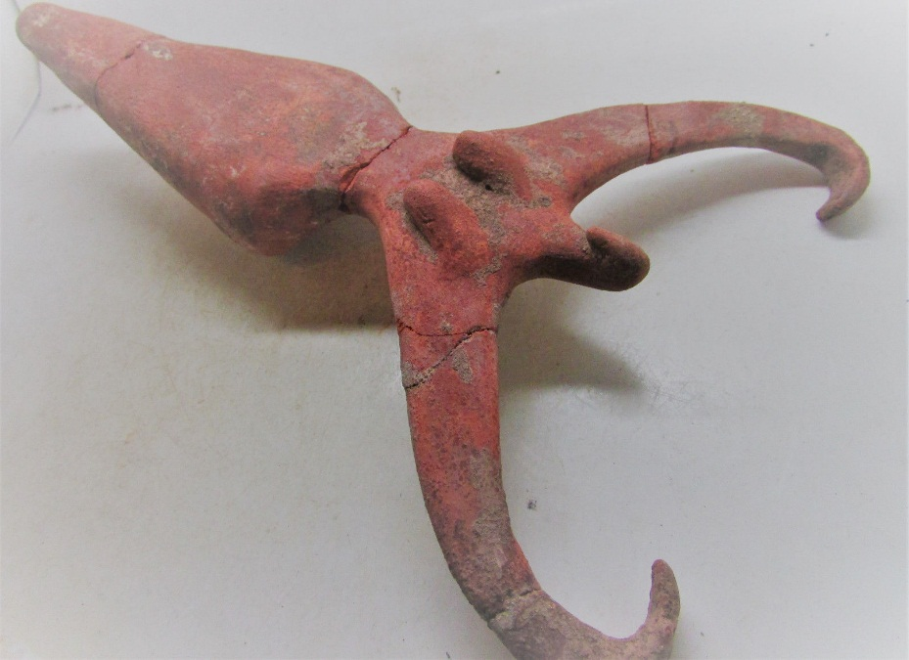

Afr-Egy-Figure-Female-Terracotta, Pigment-ca. 3500-3400 **BCE**

**Case no.: 2**

**Accession Number:**

**Formal Label:** Afr-Egy-Figure-Female-Terracotta, Pigment-Period Zero 3500-3400 **BCE**

**Display Description:**

EXTREMELY RARE Pre-Dynastic Period Zero Egyptian terra cotta, figurine of a female anthropomorph. Small head, with pronounced nose that looks like an avian beak, on a long neck, expanding to shoulders, elongated breasts suggestive of a mature woman. Her waist gracefully curves into uplifted arms with hands turned in and pointed upwards; fingers indicated by shallow grooves; wrists and elbows not indicated. Legs without feet, peg-shaped, torso proportions are elongated. "Steatopygy" is pronounced; abdomen is flat. Fine brownish pottery, painted red on body on. Very fine specimen. Condition: fractures repaired on both arms, waist and lower torso. Seemingly some repainting on torso.

Dance in the Pre-Dynastic, Period Zero, 3500-3400 BCE, is known from terracotta figurines, that may express a sacred act in rituals entreating spiritual forces, such as summoning rain and promoting fertility by performing an "artistic aesthetic" movement embodying emotions of joy, enthusiasm, alertness, fear, jealousy or sadness. These figurines depict an actual dance that was accompanied by music and costumes that gave dancers the greatest amount of "freedom of movement" to achieve an authentic “artistic aesthetic”.

Scholars still debate to this day what exactly this figure is doing. The symbolism, function, and identity of the figure are not certain. However, similar female figures painted on Pre-dynastic vessels appear to be goddesses, because they are always larger than the male "priests" shown with them. She could also represent a priestess or a goddess dancing or performing ritualized mourning at a funeral. Generally, the figure is not interpreted as having an avian head. Scholars speculate that the hook-like projection could be an emphasized nose. We know that the Egyptians thought it was important for sculptures to have noses so they could breathe when a soul was living in them. While this and other figurines like it have been found in association with burials, we don't know for certain if they were made for burials specifically or some other purpose. Based on later traditions, one can speculate that the figurine was somehow connected to the mortuary ritual or the rebirth of the deceased.

Since the 1880s, archaeologists have found in Egypt many female terracotta statuettes of this type. They are among the oldest plastic representations of Egyptian art and generally seem to come from tombs although, most of the time, their context of discovery cannot be clearly established. Most of these statuettes are female but there are also some male examples.

This statuette can be compared to a copy of the Pre-dynastic collection of the Brooklyn Museum from Ma'mariya (Upper Egypt).

The significance of such a figurine, which was presumably part of a funerary furniture, is far from being fully clarified. We can evoke a certain correspondence with some of the sets on painted vases from the same period, which sometimes include analogous female figures but with arms raised as if they performed dance movements or invocations. Some authors have attributed to them a role in relation to the hereafter, even a role of divinity or "guardian of the dead".

All the burials of the same chronological period did have statuettes of this kind: it is probable that these statuettes were attributed according to the social position of each deceased. Thus, perhaps, they could contribute to certain individuals within a ritual system whose organization and meaning still eludes us today.

Compared with other similar copies, the position of the arms seems exceptional. Indeed, they are broken under the rounded shoulders and it is difficult to admit that they were modeled raised, forming a rounded over the head, as for many other statuettes that the ancient authors qualified sometimes "dancers"; it seems more likely that the arms were placed along the body or perhaps bent at the elbows to join the belly height. In any case, it does not seem, in the current state of the studies, that there was a real canon of representation at this remote time.

Legs are not individualized and form a kind of tenon. It is possible that originally this statuette could be stuck in the ground or in any medium.

**LC Classification:**

**Date or Time Horizon:**

**Geographical Area:** This was excavated at a site called Ma'mariya in Upper Egypt, c 1906. The Brooklyn Museum sponsored the excavations and took most figurines for their collections (see Appendix). Broken fragments were sold to antiquities dealers. This figurine was reconstructed from those fragments.

**Map:**

**GPS coordinates:**

**Cultural Affiliation:**

**Medium:** terra cotta

**Dimensions:** 17.8 cm

**Weight:**

**Condition: restored**

**Provenance:**

**Discussion:**

**References:**

Appendix:

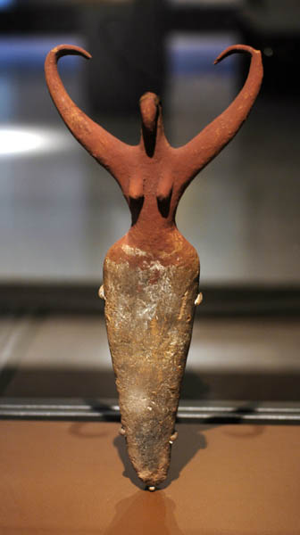

3400-3500 Egypt - BCE - Brooklyn Museum

Female Figure, ca. 3500-3400 B.C.E. Terracotta, pigment, 11 1/2 x 5 1/2 x 2 1/4 in. (29.2 x 14 x 5.7 cm). Brooklyn Museum, Charles Edwin Wilbour Fund, 07.447.505. Creative Commons-BY (Photo: Brooklyn Museum, 07.447.505_SL1.jpg)

https://upload.wikimedia.org/wikipedia/commons/4/45/Brooklyn_NY_Nov-2005_0023_7.jpg